
המחלקה להנדסת חשמל ואלקטרוניקה

מערכות לומדות ולמידה עמוקה (31245)

Lab 5 report

פרנסיס עבוד

Prepared for: Dr. Amer Adler

Date: 04/05/2025

Ex.A: Multinomial Logistic Regression (+Softmax)
1) Plot the graph of classification accuracy versus trainset size: for S=100 to 1000 in steps of 100. Compute the accuracy only on the test set.
Code:
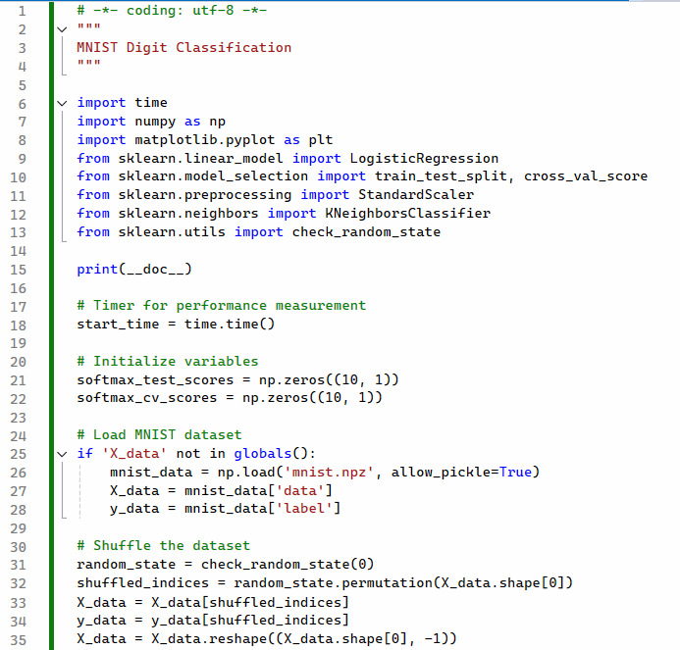
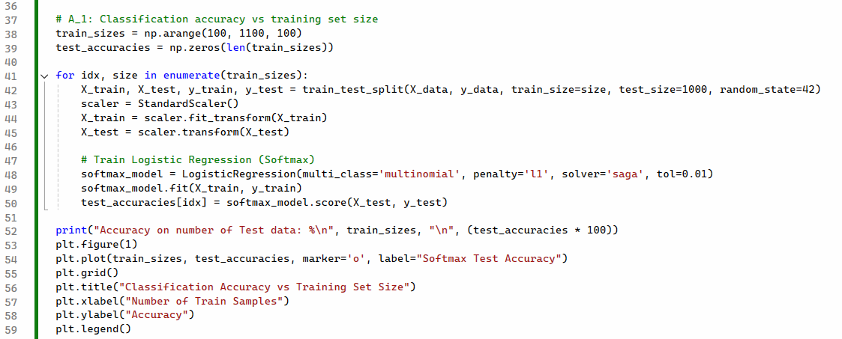
Output:
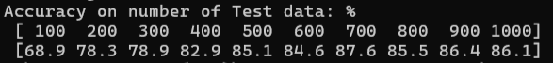
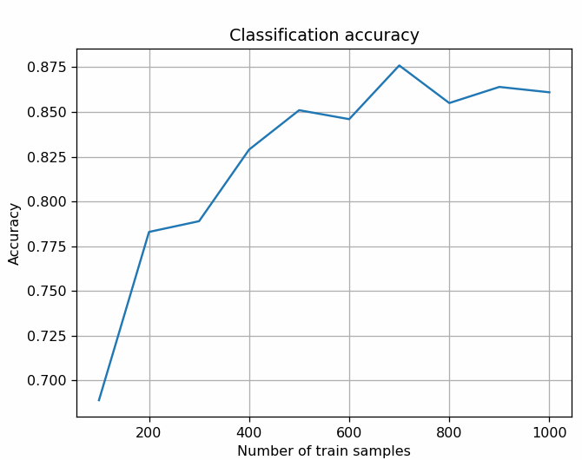

2) Compare to the same graph, but with accuracy computed with K-fold cross-validation (without testing set), and K=5.
Code:
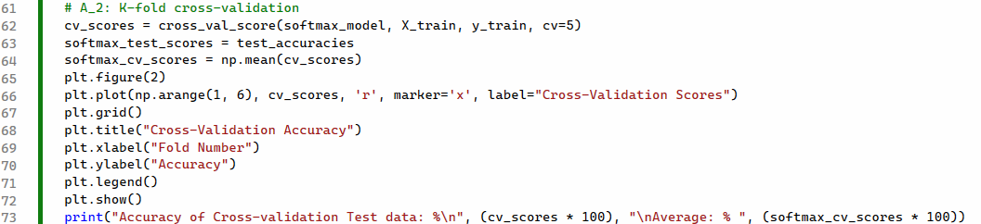

Output:
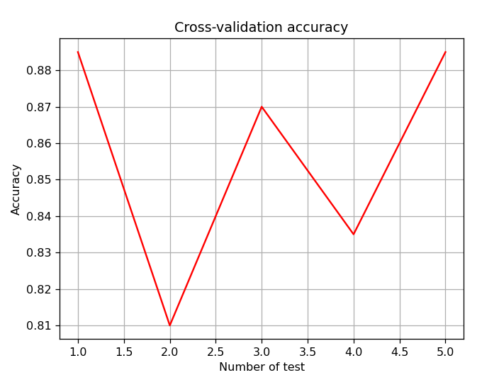

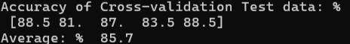

3) Display 5 wrong classified digits from the Softmax classifier, and their Softmax output probability vector.
Code:
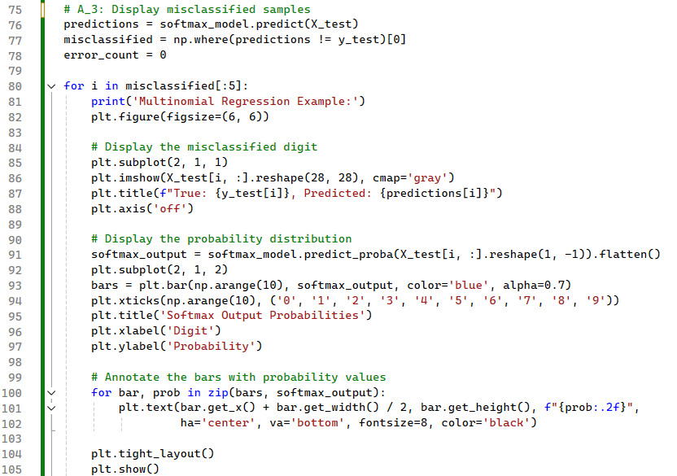
Output:
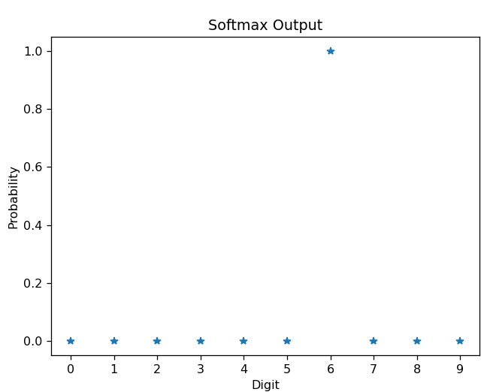
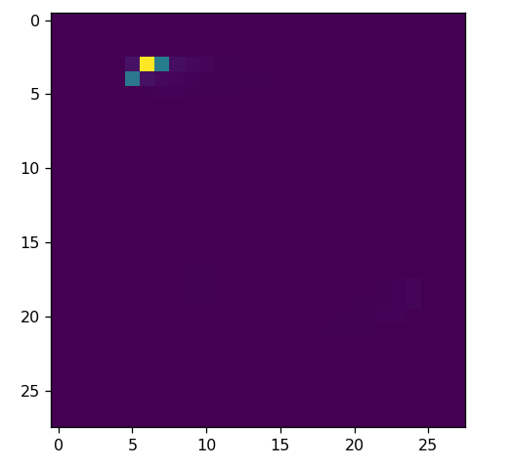
Error 1:

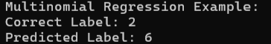

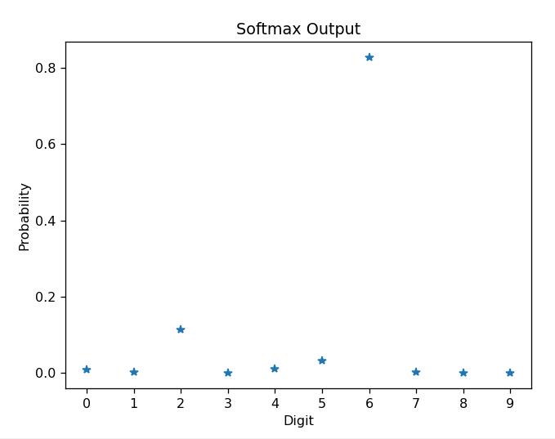
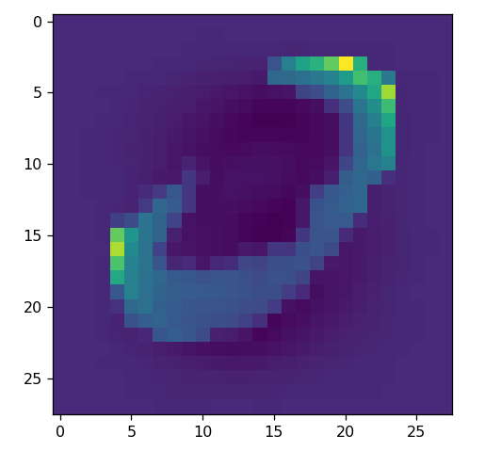
Error 2:
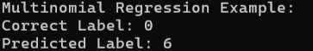
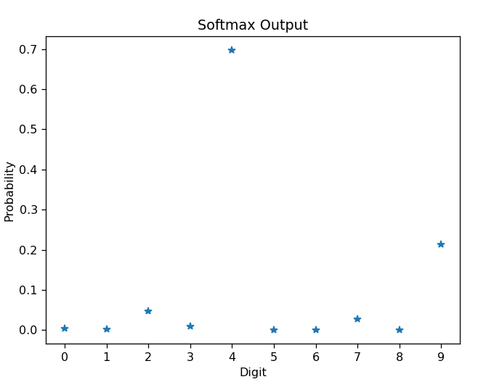
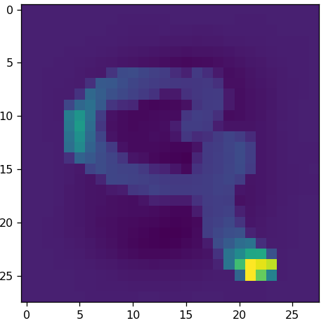
Error 3:
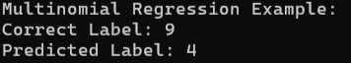
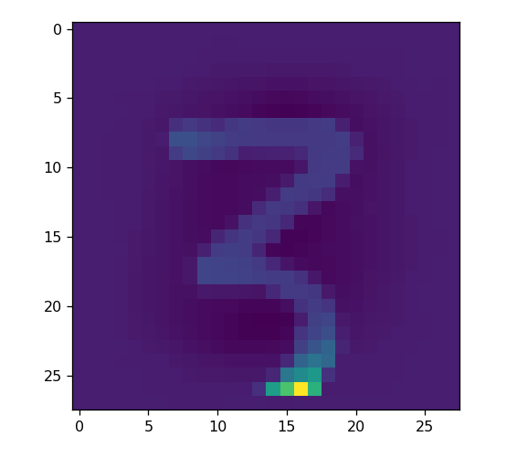
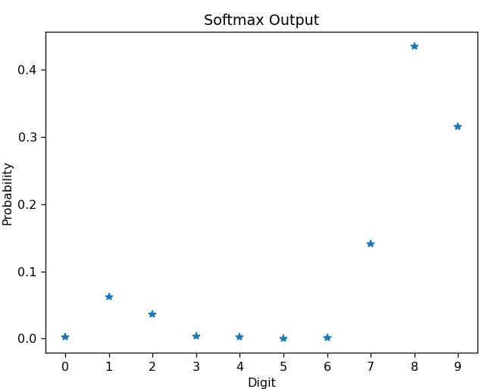
Error 4:

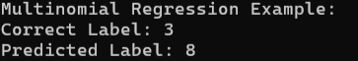
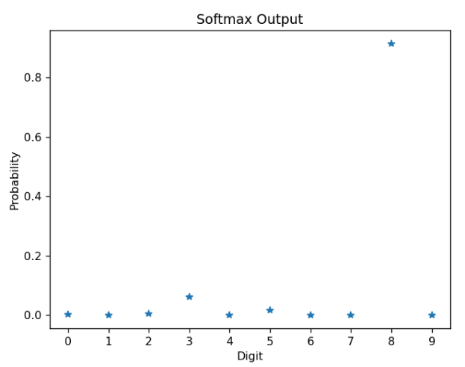
Error 5:
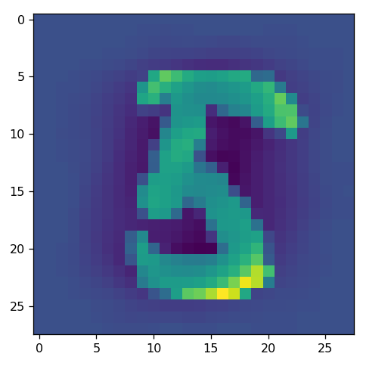
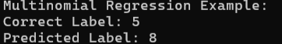

Ex.B: K-NN
4) Train a K-NN classifier, using 3 different values of K between 3 to 10 and choose the K which gives the best accuracy for S=500.
Code:
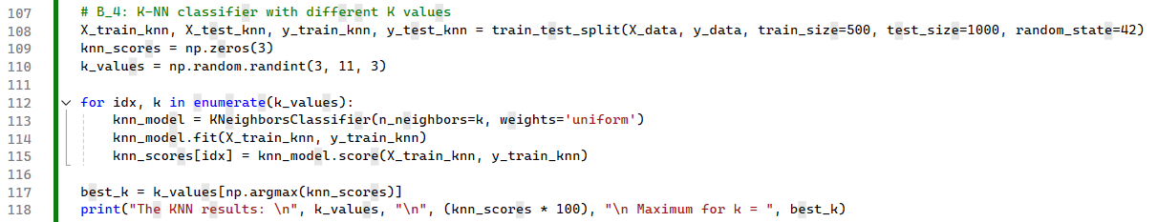
Output:
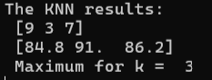

5) Plot the graph of K-NN classification accuracy (with K as chosen in task 4) versus trainset size: for S=100 to 1000 in steps of 100. Compute the accuracy only on the test set. Draw also the graph of task (1) on the same plot.
Code:
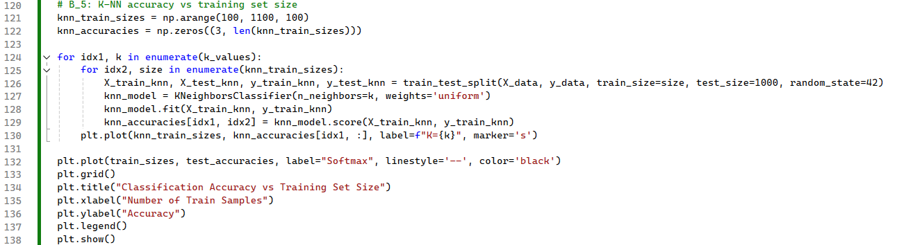
Output:
